1. **Assignment:** Download, Install and do the Configuration of cloudsim.

**Step 1:** To Install Ellipse IDE, Go to Website → [www.eclipse.org](http://www.eclipse.org) → Then Click Download file for x86_64

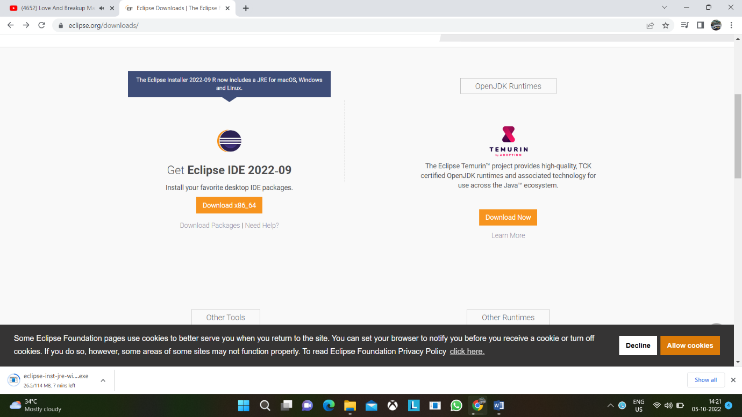

→ Extract the file → open to Install Ellipse IDE → Select for Java Developer to install

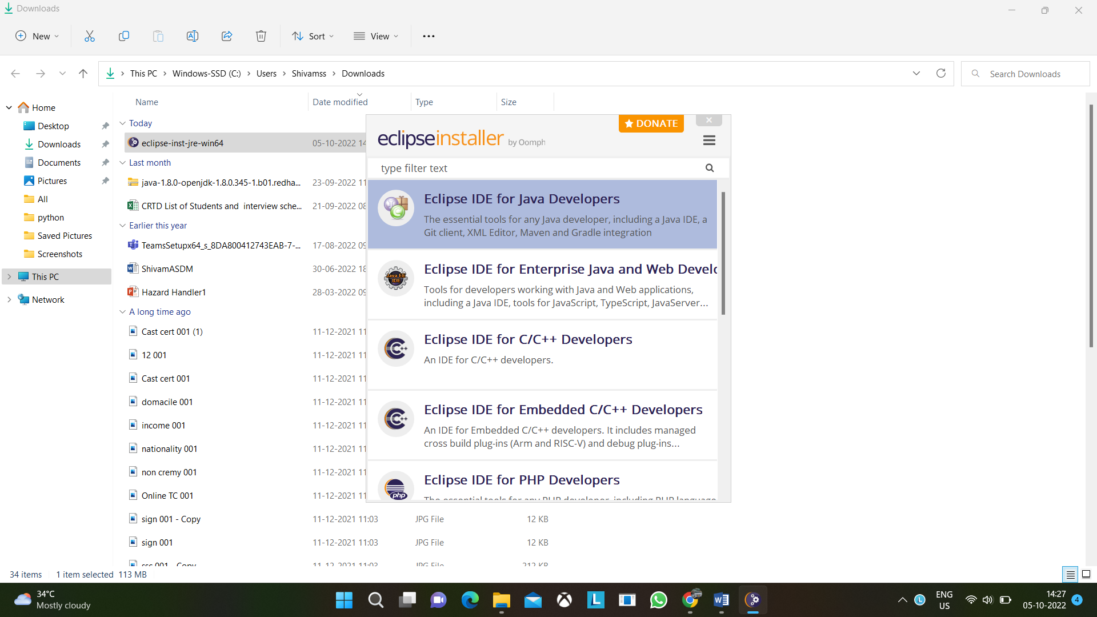

Now we in install jar files of cloudsim

**Step 2:** Go To <https://code.google.com/archive/p/cloudsim/downloads> 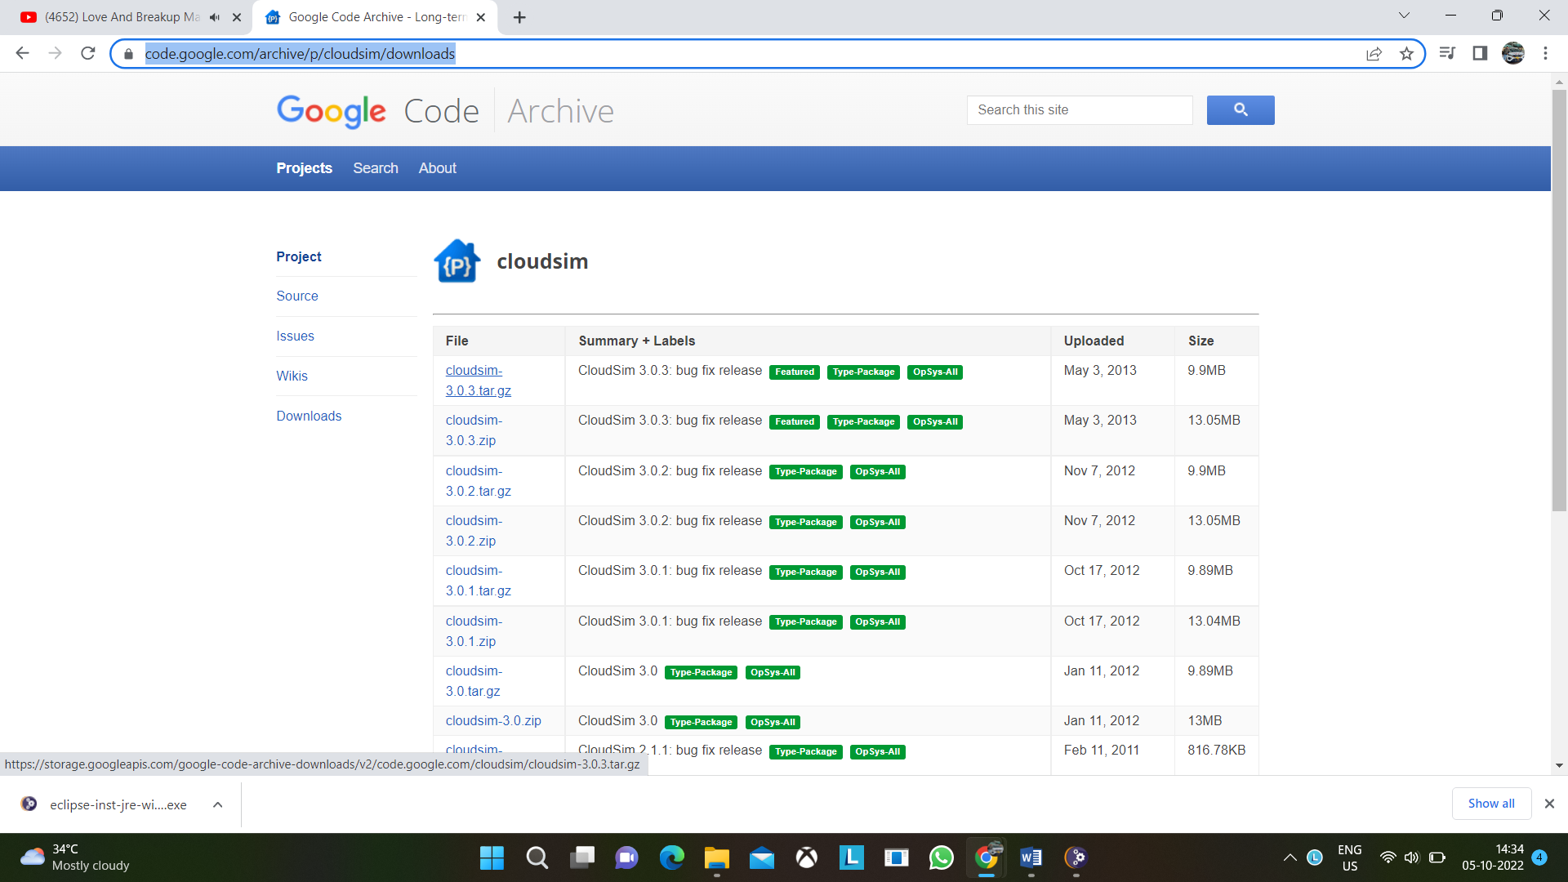

Select cloudsim 3.0.3 tar.gz file & download it and extract it.

**Step 3:** Before importing jar files place jar files in same project folder

Open Ellipse IDE → Click on File → New → Project → Java Project → Name the project & click on next button → Select Libraries → Click on Add Jars → Select cloudsim folder and go to jar folder select jar files Done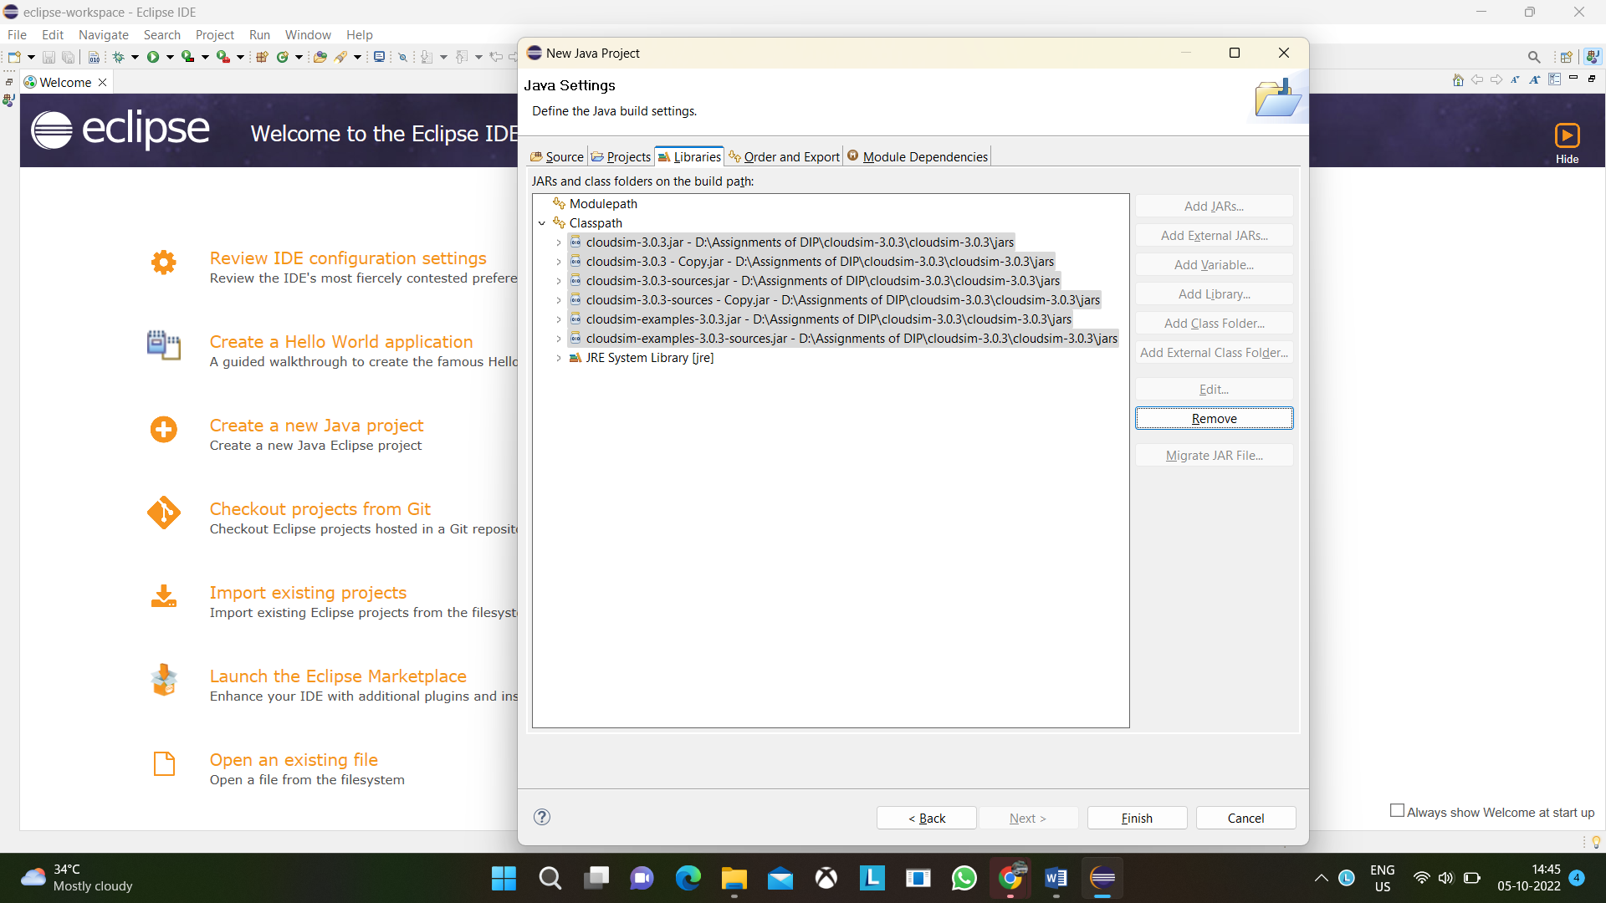

**Step 4:** To add jar files in existing project do as follows Right Click on Module Name → Select Build Path Option or go to properties → Go to Libraries → Click on class path → do as step 3

1. **Assignment:** Downloading and Installing Cloud Analyst

**Step 1:**

Download Cloud Analyst NetBeans project from the below mentioned link <https://sourceforge.net/projects/cloudanalystnetbeans/>

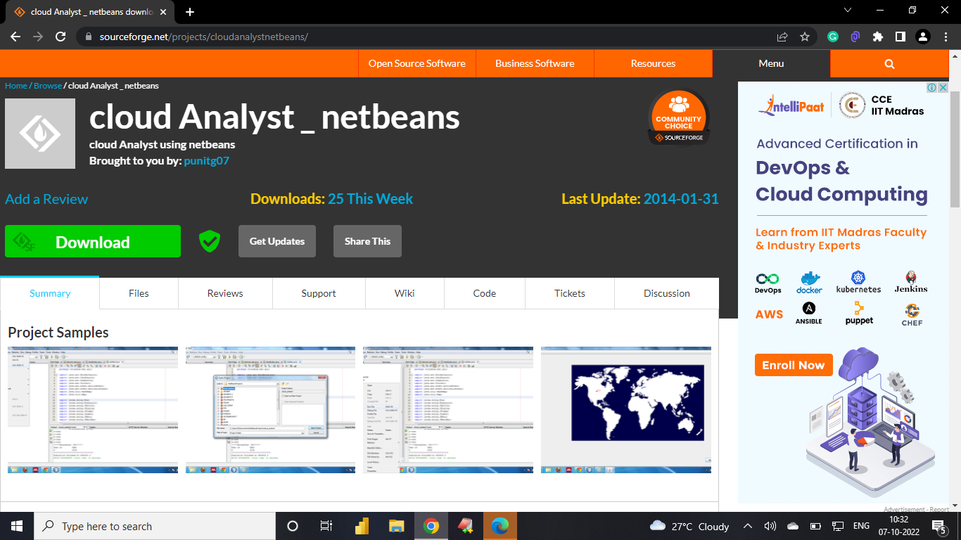

**Step 2:**

To run the cloud analyst got to NetBeans File → open project → browse the unzipped folder

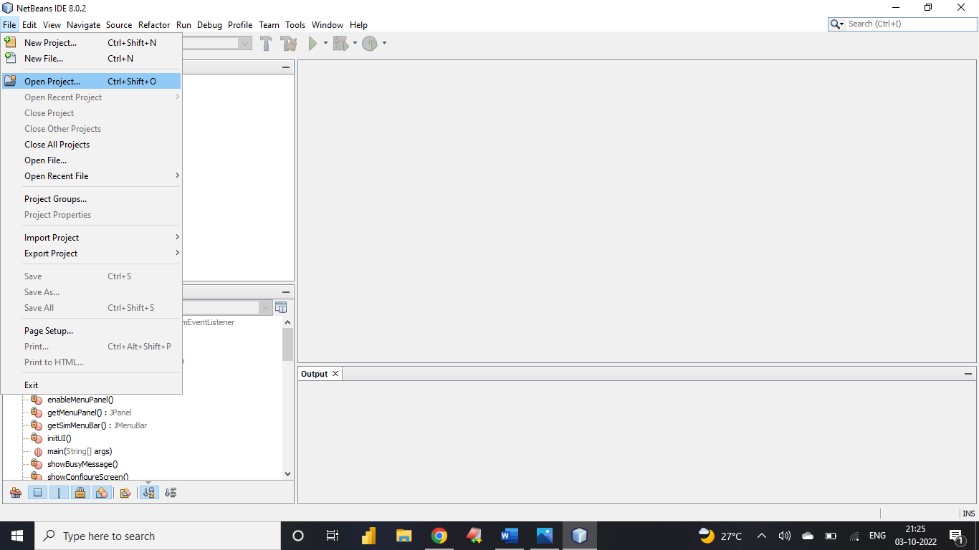

**Step 3:**

Browse the unzipped folder that you have downloaded.

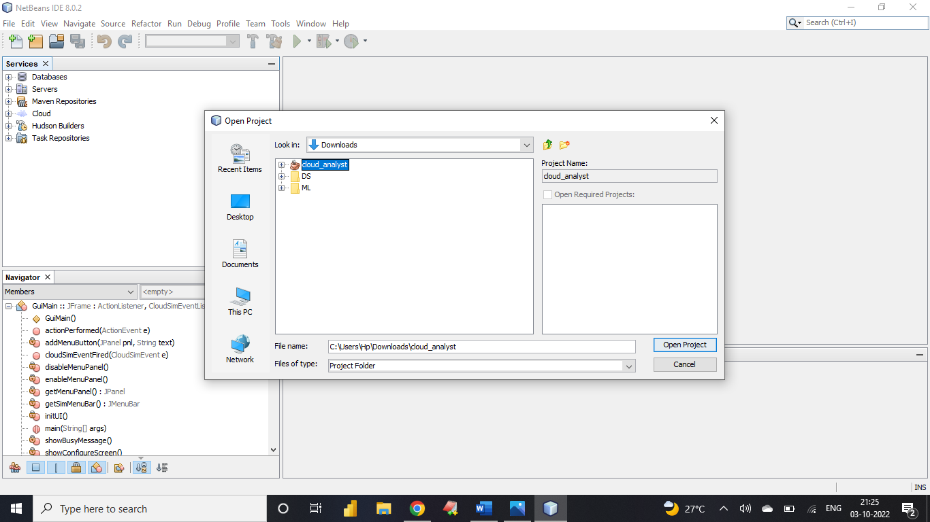

**Step 4:**

Open-source package folder inside which open cloudsim.ext.gui

right click on the gui.main.java and click run

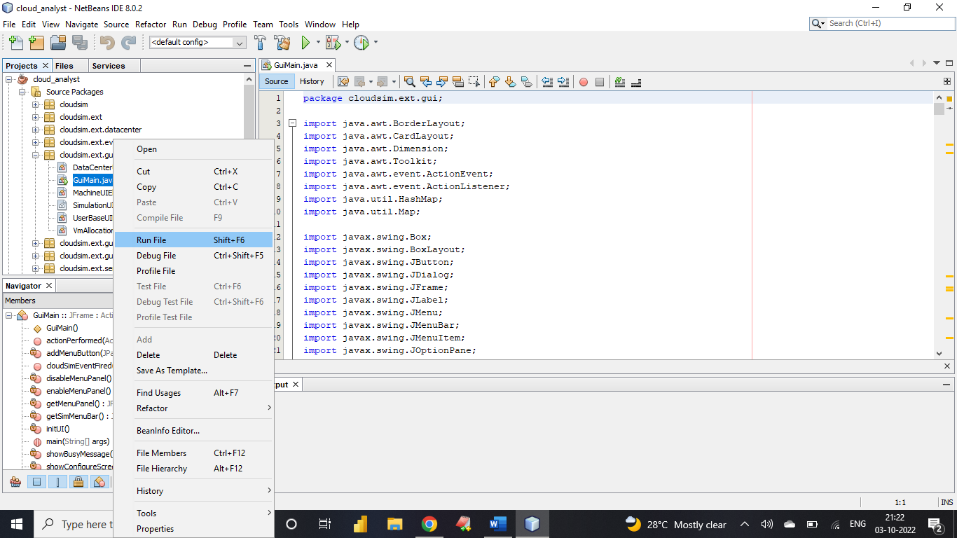

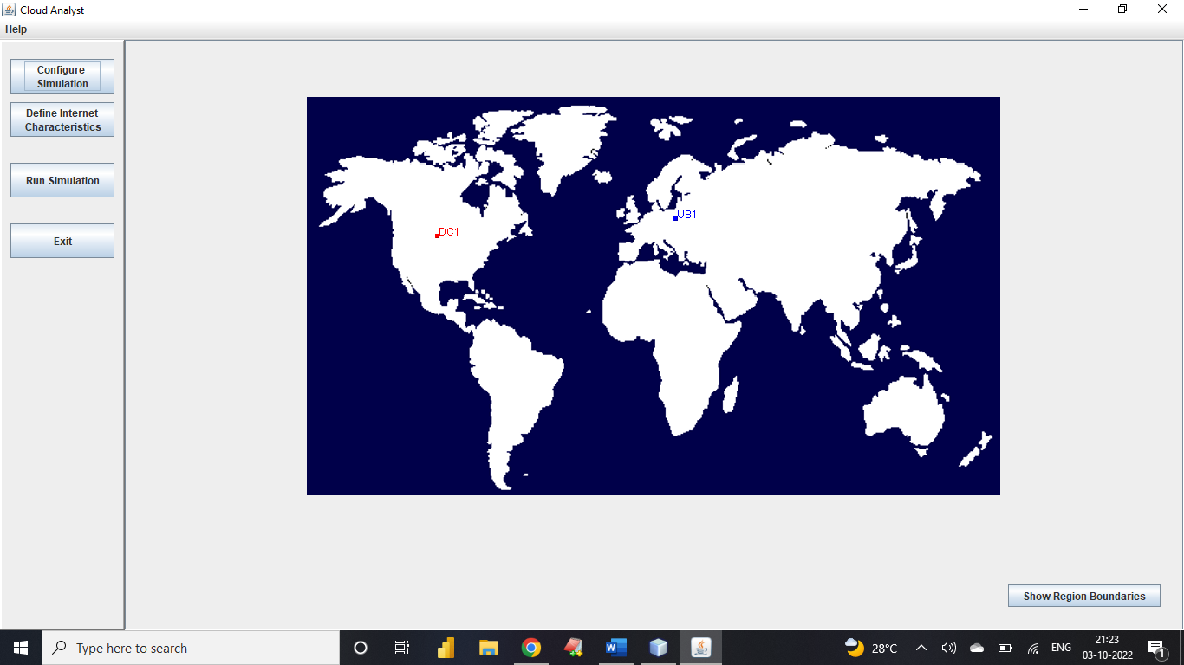

1. **Assignment:** Creating a Warehouse Application in SalesForce.com.

**Step 1:** Log into your Sandbox or Developers Organization.

<https://developer.salesforce.com/signup>

Click on setup → create → objects → new custom objects.

Label: MySale

Plural Label: MySales

Object Name: MySale

Record Name: MySale Description

Data Type: Text

Click Save.

**Step 2:** Under MySale Go to Custom Field and Relationships → Click on New Custom Field

**Creating 1st Field:**

Select Data type as Auto Number → Next →

Enter the detail Field Label: PROD_ID → Next → Next → Save & New

Starting Number: 1001

**Creating 2nd Field:**

Select Data type as Auto Date → Next →

Enter the detail Field Label: Date of Sale → Next → Next → Save & New

**Creating 3rd Field:**

Select Data type as Auto Number → Next →

Enter the detail Field Label: Quantity Sold Length: 3 Decimal Places: 0 → Next → Next → Save & New

**Creating 4th Field:**

Select Data type as Auto Currency → Next →

Enter the detail Field Label: Rate Length: 4 Decimal Places: 2

Default Value: 10 → Next → Next → Save & New

**Creating 5th Field:**

Select Data type as Auto Currency → Next →

Enter the detail Field Label: Quntity__c*Rate__c → Next → Next → Save

**Step 3:**

Now create a Tab

Click on setup → create → tabs → new custom tab → choose MySale → Next → Next → Save.

**Step 4:**

Now create an App

Click on setup → create → Apps → new → custom app → next → Enter My Shop for the App Label → Next → visible to all → click on save.

On the top in the tab bar you can see the tab which has been created by you click on the tab you can see your object is opened just click on new button and provide the details mentioned.

1. **Assignment:** Creating an Application in SalesForce.com using Apex programming Language.

**Step 1:** Log into your Sandbox or Developers Organization.

<https://developer.salesforce.com/signup>

Click on setup → create → objects → new custom objects.

Enter Book for Label.

Enter Books for Plural Label.

Click Save.

**Step 2:** Now let‘s create a custom field.

In the custom field & relationship section of the Book Object click new.

Select Number for the datatype & next.

Enter Price for the field Label.

Enter 16 in the length text box.

Enter 2 in the decimal places & Next → Next → Save.

**Step 3:** Click on setup → Develop → Apex classes & click new

In the class Editor enter this class

(Book__c is object API Name & Price__c is custom field API Name)

public class MyHelloWorld

{

public static void applyDiscount(Book__c[] Books)

{

for(Book__c b:Books)

{b.Price__c*=0.9;}

}

}

**Step 4:** Add a Trigger

A trigger is a piece of code that can execute objects before or after specific data manipulation language events occurred.

Click on setup → create → objects → click the object you have created ex:

Book Scroll down you can see Trigger Click on New

In the trigger Editor enter this class

trigger HelloWorldTrigger on Book__c(before insert)

{

Book__c[] Books=Trigger.new;

MyHelloWorld.applyDiscount(Books);

}

**Step 5:** Now create a Tab

Click on setup → create → tabs → new custom tab → choose Book→ Next → Next → Save.

**Step 6:** Now create an App

Click on setup → create → Apps → new → custom app → next → Enter My Book Shop for the App Label → Next → visible to all → click on save.

**Step 7:** Now Insert a Book

Click on My Book Shop → Books → new → insert a name for Book → insert price for that book → click on save.

1. **Assignment:** Implementation of SOAP Web services in C# Application.

**Step 1:** Open Visual Studio → Go to File → Select New → Web site → ASP.NET Empty Web Site

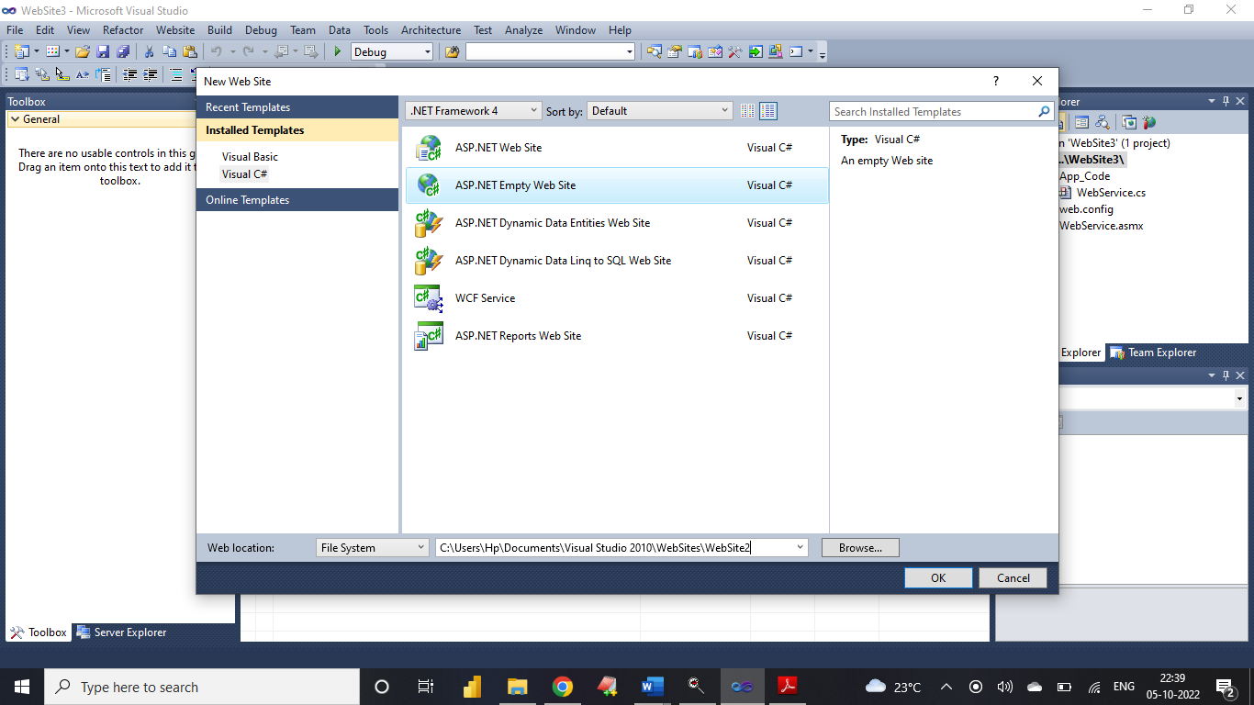

**Step 2:** Right Click on website Menu → Add New Item → Web Service →

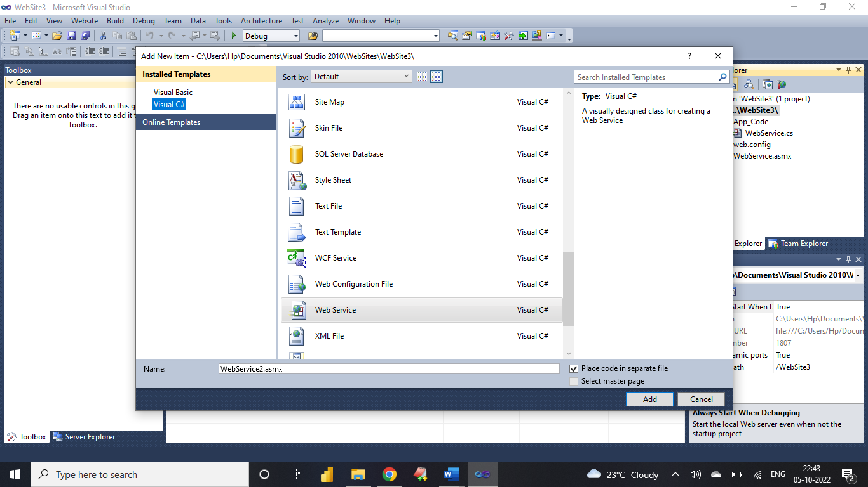

**Add following code**

[WebMethod]

public int add(int a, int b)

{

return a + b;

}

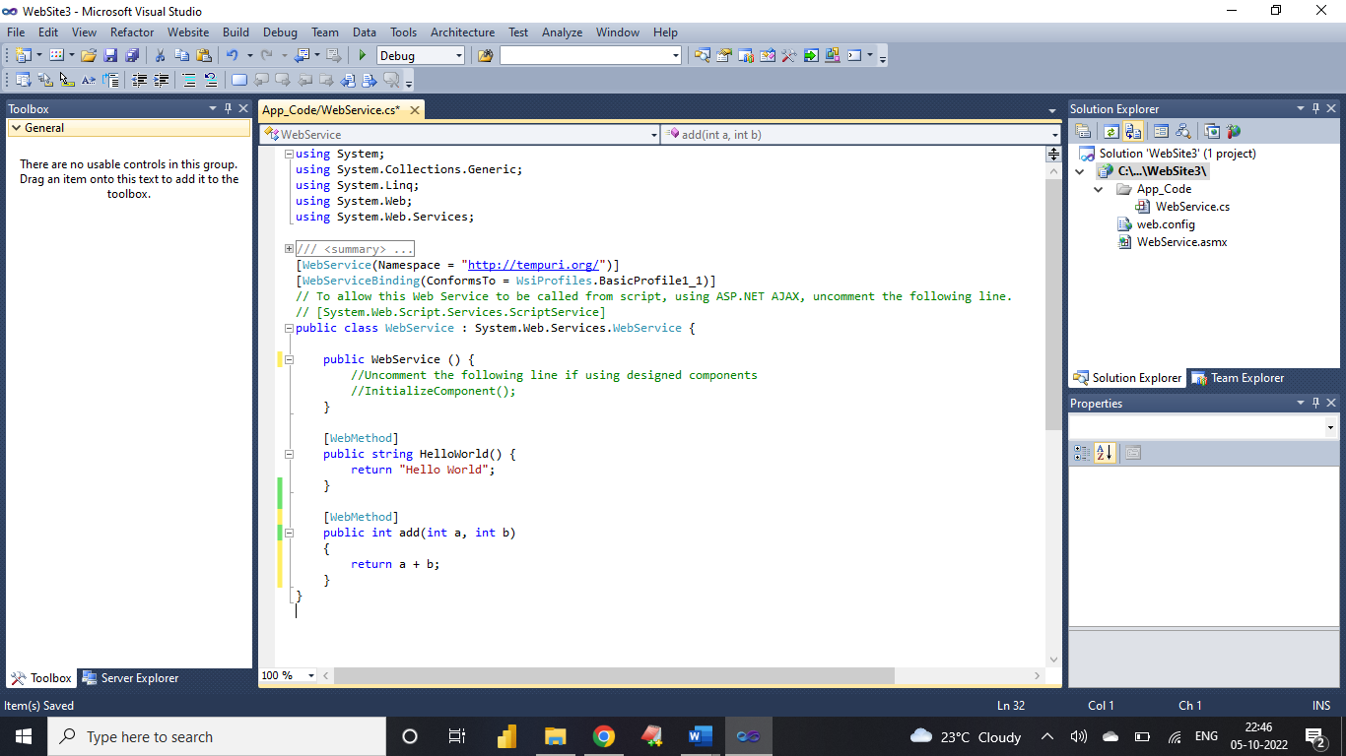

Test your web service by pressing F5 button on Keyboard

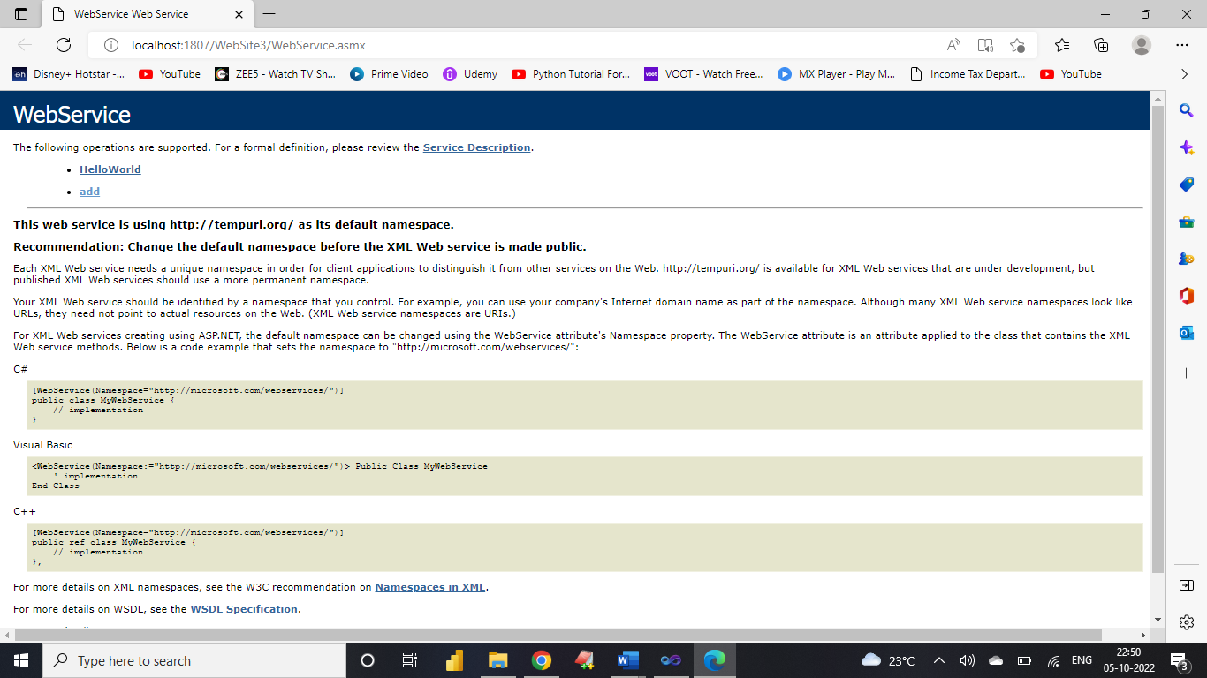

**Click on add**

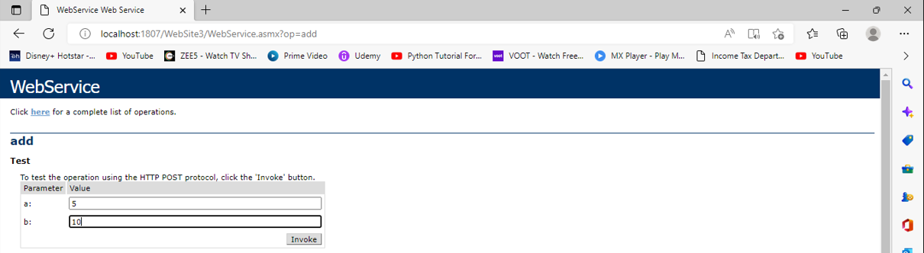

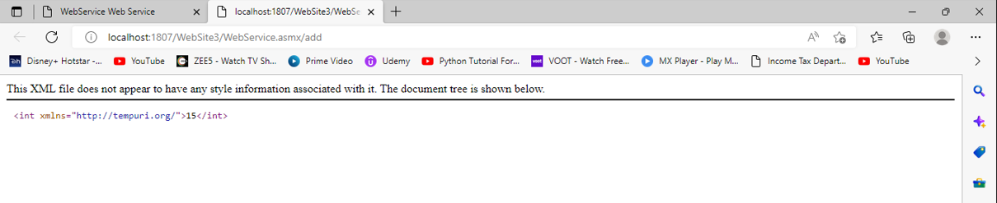

Copy URL of Web service ( having extension .asmx)

**Step 3:** Right Click on website Menu → Add Web Reference → Paste the URL copied earlier

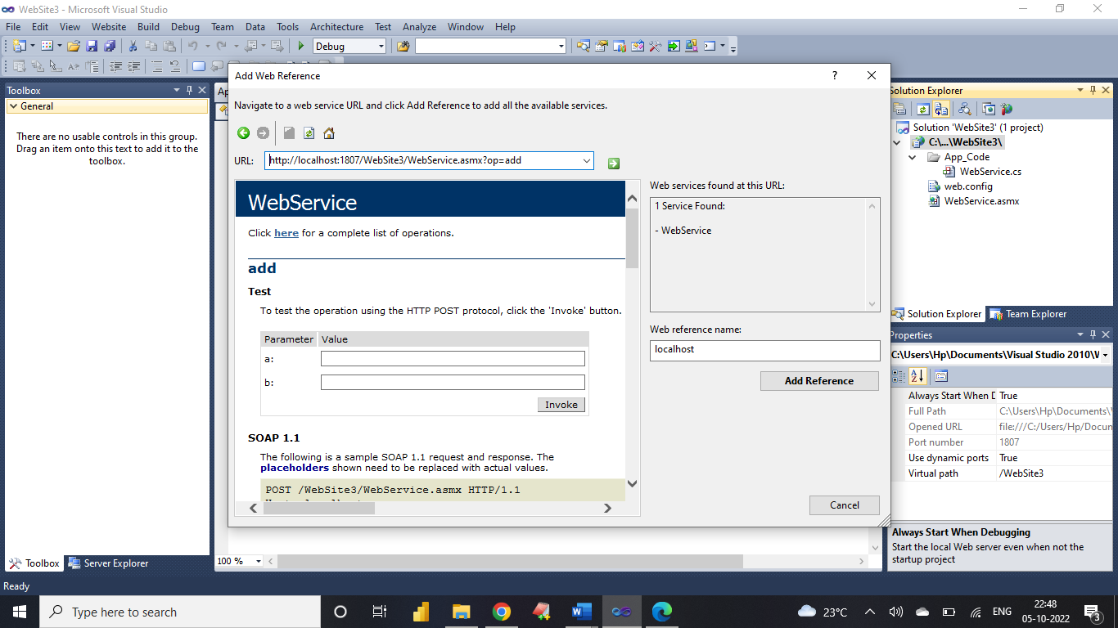

**Step 4:** Now create application for addition and add following code

Right Click on website Menu → Add New Item → Web Form

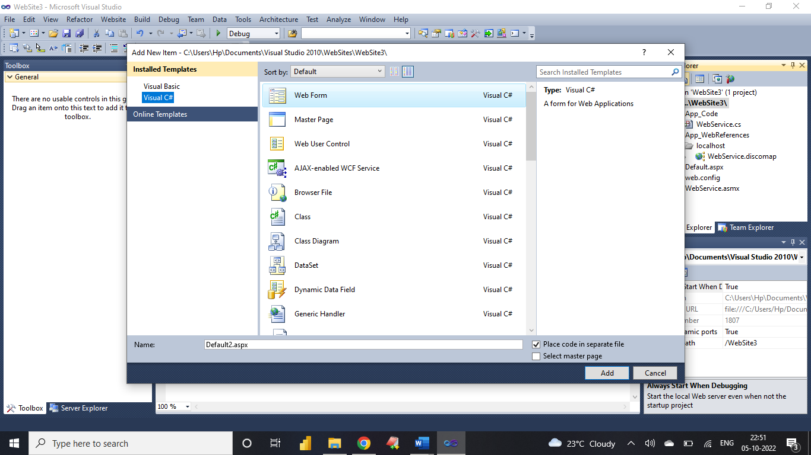

Now Double Click on Add Button Type This Code

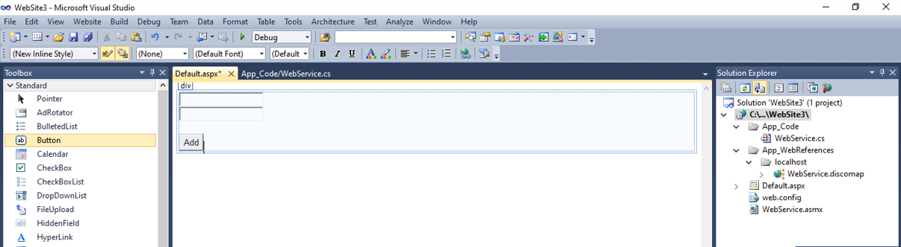

using System;

using System.Collections.Generic;

using System.Linq;

using System.Web;

using System.Web.UI;

using System.Web.UI.WebControls;

public partial class _Default : System.Web.UI.Page

{

int n1, n2, res;

protected void Page_Load(object sender, EventArgs e)

{

}

protected void Button1_Click(object sender, EventArgs e)

{

localhost.WebService s = new localhost.WebService();

n1 = Convert.ToInt32(TextBox1.Text);

n2 = Convert.ToInt32(TextBox2.Text);

res = s.add(n1, n2);

Response.Write("Addition is " + res);

}

}

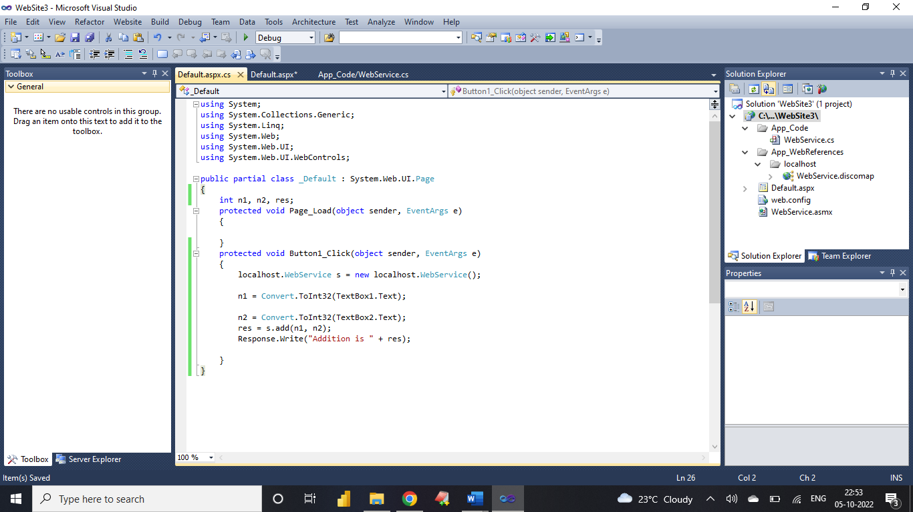

**Run the Application**

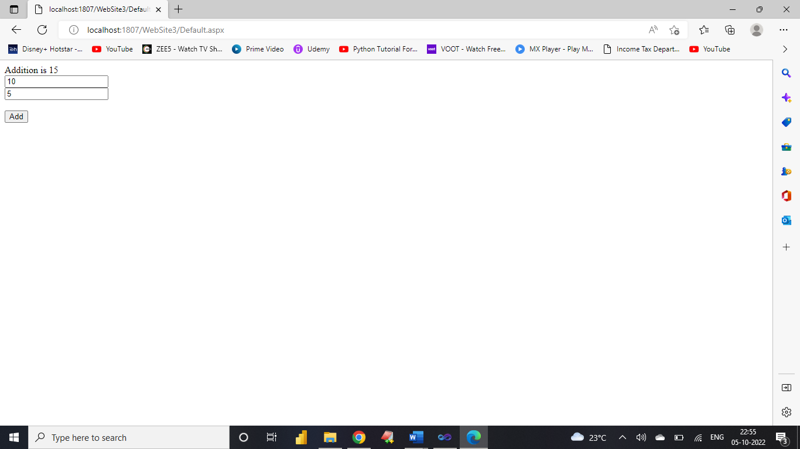

1. **Assignment:** Implementation of Para-Virtualization using VM Ware ‘s Workstation/ Oracle‘s Virtual Box and Guest O.S.

**Download and Install VirtualBox**

To download the VirtualBox, follow the instructions below.

**Step 1:** To download the latest version of VirtualBox, visit the official [VirtualBox](https://www.virtualbox.org/wiki/Downloads) website in your web browser.

**Step 2:** Now, download the VirtualBox from here.

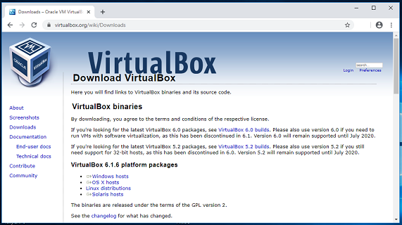

**Step 3:** Navigate the folder where you have downloaded your VirtualBox and double-click on the downloaded "VirtualBox" file to run it.

**Step 4:** "Oracle VM VirtualBox 6.1.6 Setup" window will appear on the screen and click on the "Next" button to proceed.

**Step 5:** Choose the location where you want to install the VirtualBox and click on the "Next" button to proceed.

**Step 6:** Choose the options as per your choice and click on the "Next" button.

**Step 7:** Click on the Yes button and then the "Install" button.

**Download Ubuntu**

Follow the instructions below to download the Ubuntu ISO file.

**Step 1:** To download the latest version of Ubuntu, i.e., Ubuntu, visit the official [Ubuntu](https://ubuntu.com/download/desktop) website in your web browser.

**Step 2:** By clicking on the "Download" button, you can download the latest version of Ubuntu, i.e., Ubuntu 20.04 LTS (long term support).

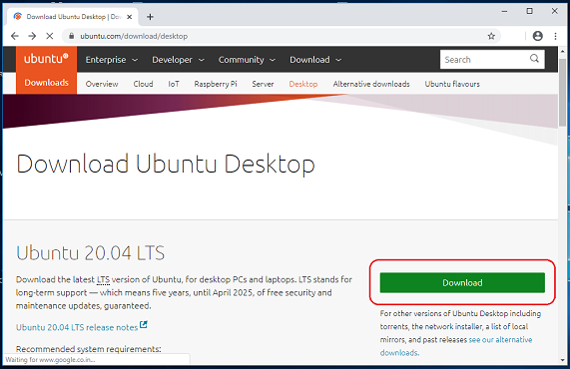

**Creating a Virtual Machine**

Now, it is time to create a Virtual Machine. Follow the instructions below to proceed.

**Step 1:** Open VirtualBox and click on the "New" button.

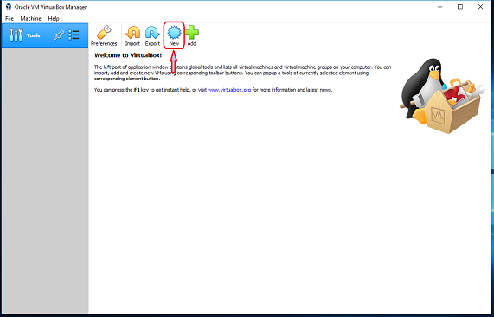

**Step 2:** Choose a name for your virtual machine with its location. Based on the name you entered, VirtualBox will try to predict the "Type" and "Version". Otherwise, from the drop-down menu, select "Linux" as the type and "Ubuntu" as the version and click on the "Next" button.

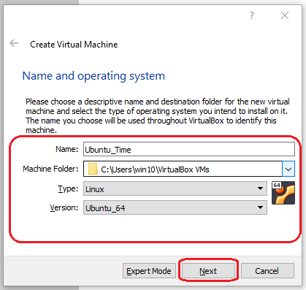

**Step 3:** With the help of the slider, choose the amount of memory (RAM) to be allocated to the virtual machine. (The recommended memory size is 1024 MB (1 GB). Please note that this memory will only be used while using a virtual machine).

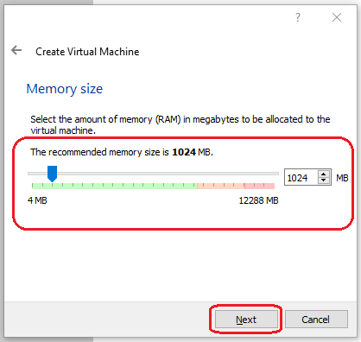

**Step 4:** Select "Create a virtual hard disk now" option and click on the "Create" button to proceed.

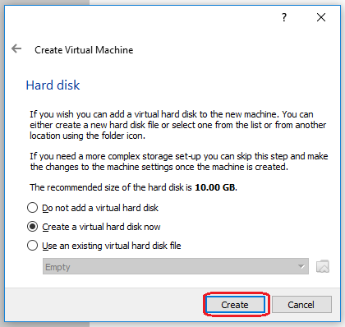

**Step 5:** Choose the "VDI (VirtualBox Disk Image)" option and click "Next".

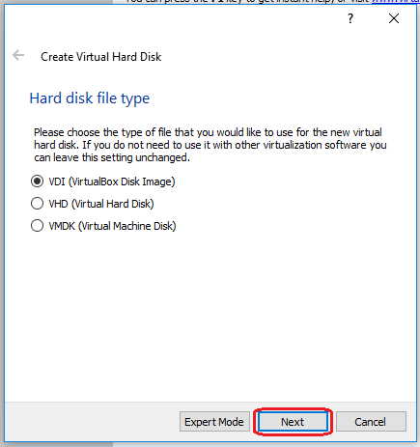

**Step 6:** Again, click on the "Next" button.

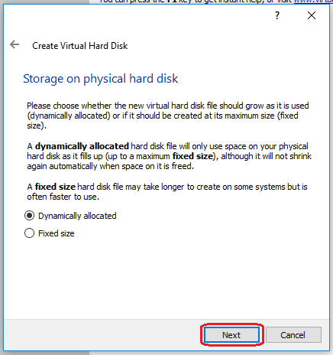

**Step 7:** Select the amount of space for your virtual machine and click the "Create" button. (This will be used for your operating system which is going to be installed, so give as much space as possible).

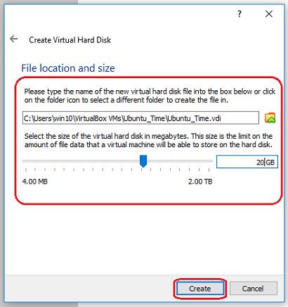

**Step 8:** When you click on the "Close" button of your virtual machine window (at the top right of the window, just like you would close any other window on your system), VirtualBox asks you whether you want to "save" or "power off" the VM. (As a shortcut, you can also press the Host key together with "Q".)

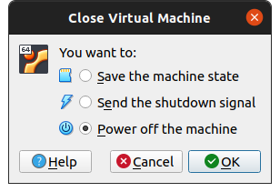

1. **Assignment:** Installation and Configuration of Hadoop.

First of all, you need to install Java since Hadoop is based on it. Then, you need to download and configure Hadoop File System itself. Also, I recommend you to have [WinRAR](https://www.winrar.es/descargas) installed because you will need to extract some files.

**Java Installation and Configuration**

Java Download

As stated in [Hadoop Java Versions](https://cwiki.apache.org/confluence/display/HADOOP/Hadoop+Java+Versions):

Apache Hadoop 3.3 and upper supports Java 8 and Java 11 (runtime only), but Hadoop compilation with Java 8 is mandatory.

Apache Hadoop from 3.0.x to 3.2.x now supports only Java 8.

Apache Hadoop from 2.7.x to 2.10.x support both Java 7 and 8.

In this guide, I will explain how to install Hadoop 3.1.3, so you need Java 8.

First of all, you need an Oracle account. If you don’t have one [create it here](https://profile.oracle.com/myprofile/account/create-account.jspx). The procedure is very straightforward, you just need to complete a form and verify your email.

After your Oracle account is created, you need to go to [Windows Java 8 SE Development Kit official download site](https://www.oracle.com/java/technologies/downloads/#java8-windows) and download the x64 Installer:

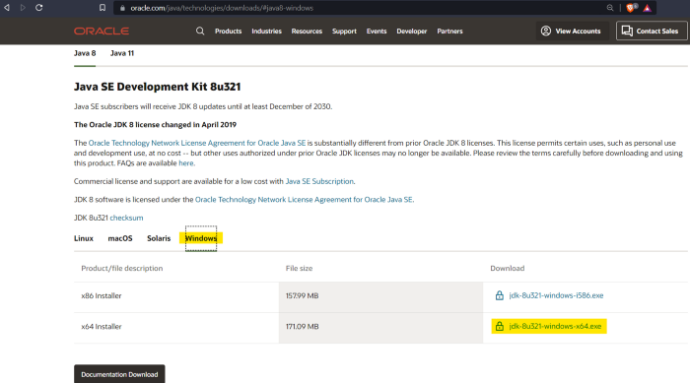

Then, you will be asked to accept (clicking on the checkbox) the [Oracle Technology Network License Agreement for Oracle Java SE](https://www.oracle.com/downloads/licenses/javase-license1.html#licenseContent). Once the checkbox is marked, click the button to download the installer:

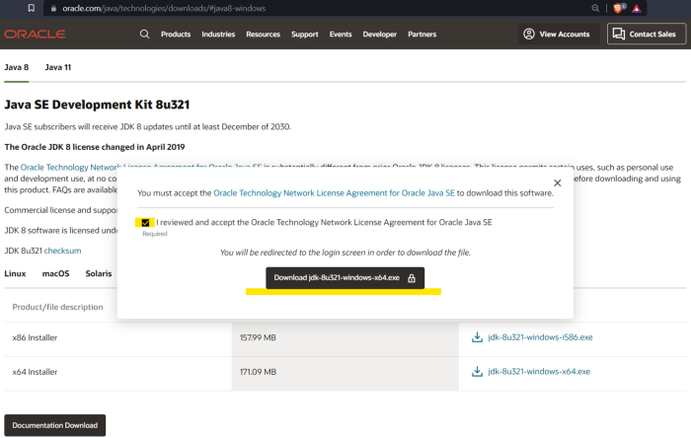

After that, you will be asked to sign in with your Oracle account and then the installer download will start immediately:

**Java Installation**

Then, you must proceed with the Java installation. Just open the folder where installer is in and run it:

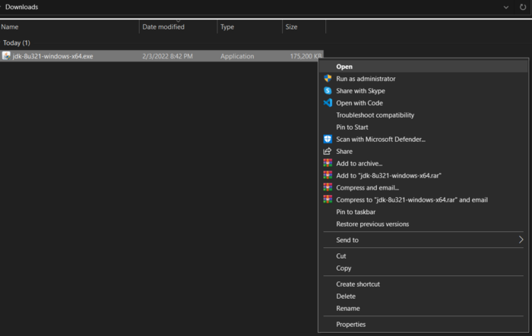

Next, the installation wizard will be shown, click on Next in the following two views:

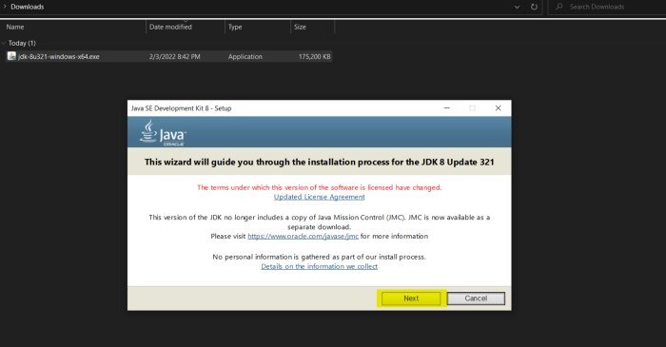

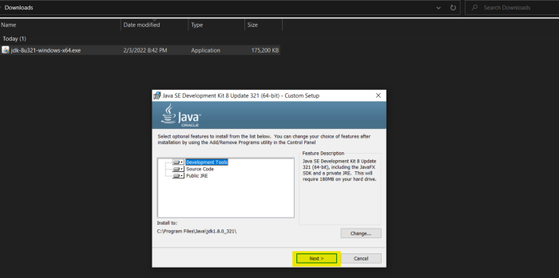

The third view is to select the destination folder where SDK files will be stored. Here, you need to create the folder “Java” in the root path of your storage drive

1.- Select Change:

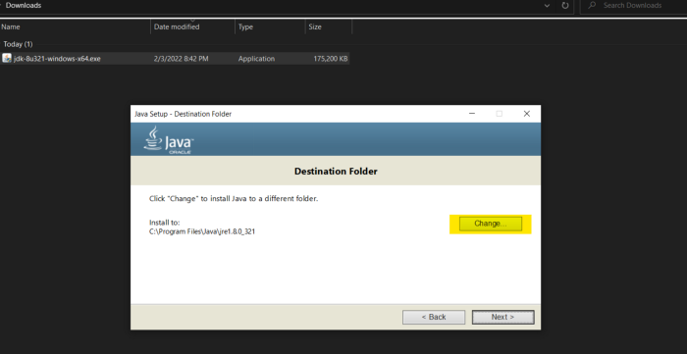

2.- In the Browse for Folder window, select your storage drive (In my case, the C: drive), click on Make New Folder button and assign the name “Java” to the new directory, then click OK:

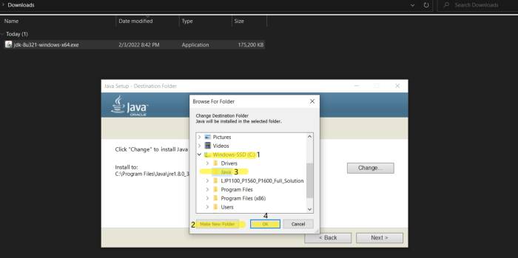

After that, you need to check if the destination folder has been updated. Once you have verified it, click on Next > and wait the installation to finish:

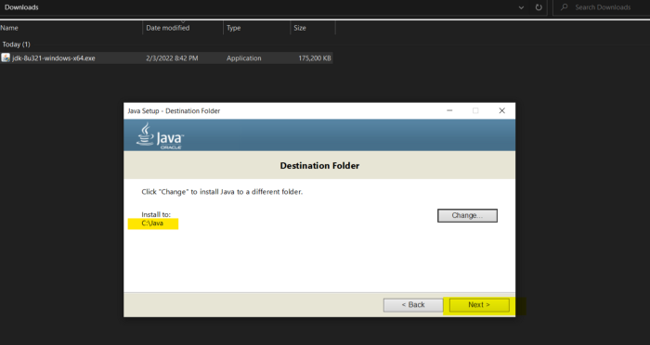

When this view displays, the installation has been finished and you can close the wizard:

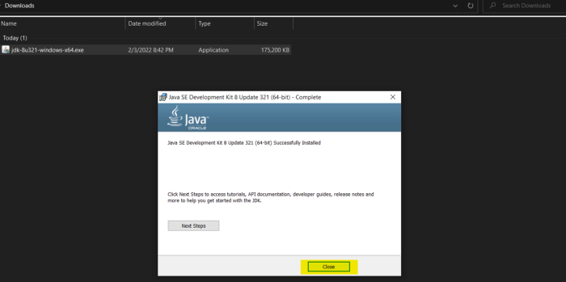

After this, you will see that there are two folders named “Java” the one you’ve just created and the other one will be inside the “Program Files” folder in your storage drive, the latter was created by the Java Installation Wizard:

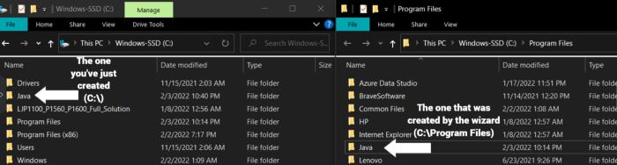

You need to move the content of the folder created by the wizard (C:\Program Files\Java) to the Java folder you have created (C:\Java) to avoid problems latter when you configure the environment variables:

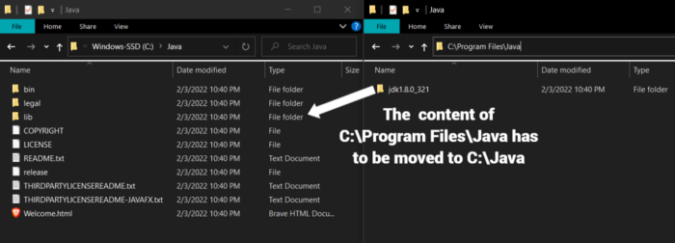

After that, C:\Program Files\Java folder will be empty:

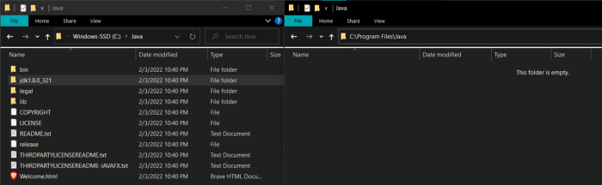

Then, you need to remove C:\Program Files\Java. As you can see, this folder no longer exists:

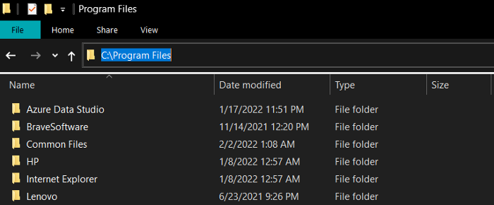

**Java Environment Variable Configuration**

Now, you need to create an environment variable for Java. To do so, type “Edit the system environment variables” in the Windows search bar and select that option:

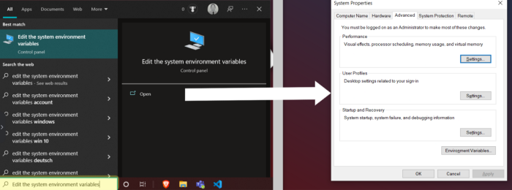

In the “System properties” view click on Environment Variables to open that window:

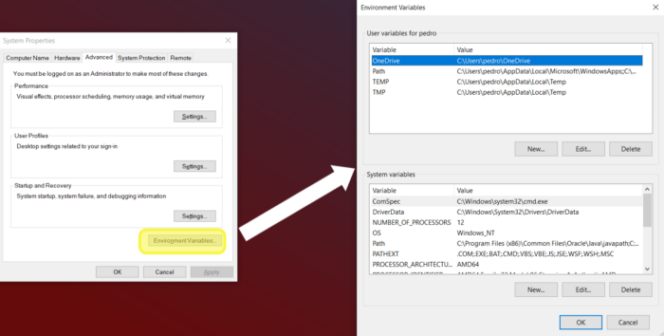

Now, in the “Environment Variables” window click on the New… button of the “User variables for <username>” panel. After that, “New User Variable” window will appear; there, you have to create the JAVA_HOME variable. In the Variable value field you need to write the path of the bin directory which is inside of the jdk folder. Recall that jdk folder is located inside of the Java folder you previously created in the root of your storage drive. In my case I had to write C:\Java\jdk1.8.0_321\bin:

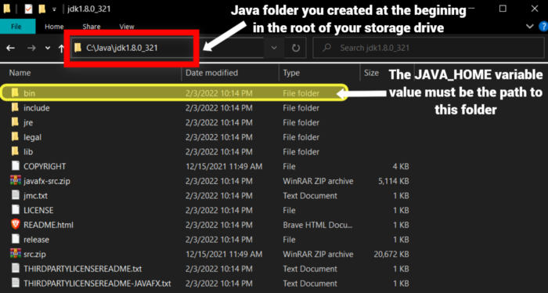

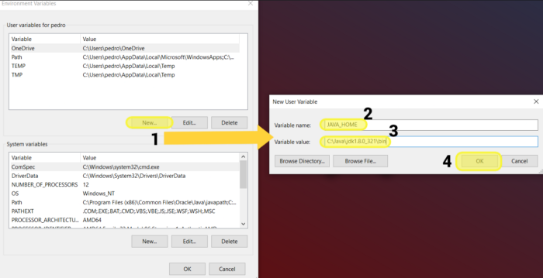

When you click on OK, the previous window will close and you can see the new variable at the top of the User variables for <username> list:

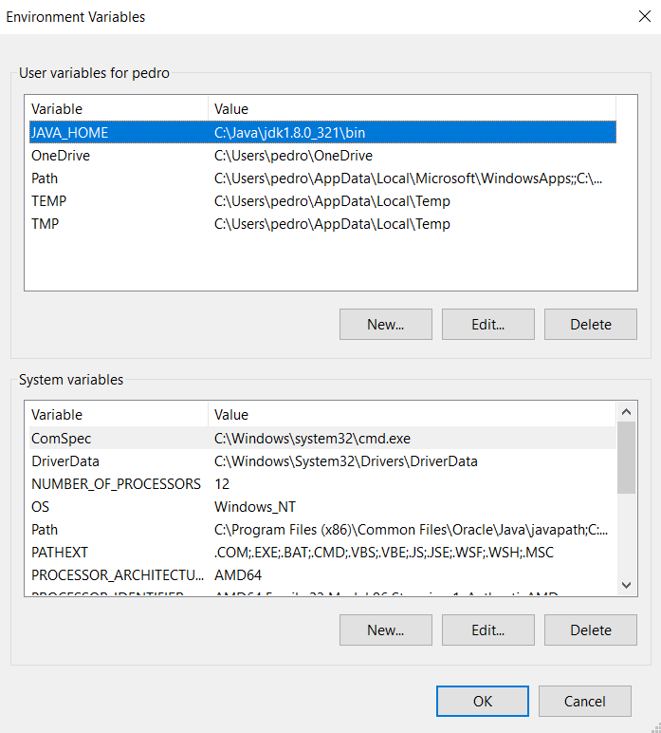

Now, in the System variables panel, find the Path variable, select it and click on Edit... to open the Edit environment variable window:

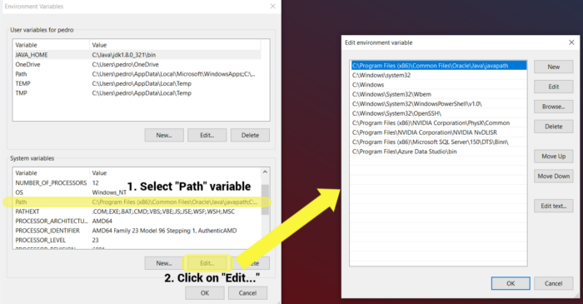

In the Edit environment variable window, click on New and write the path to the jdk folder, the exact same path you’ve just assign to the JAVA_HOME user variable. Then, click on OK:

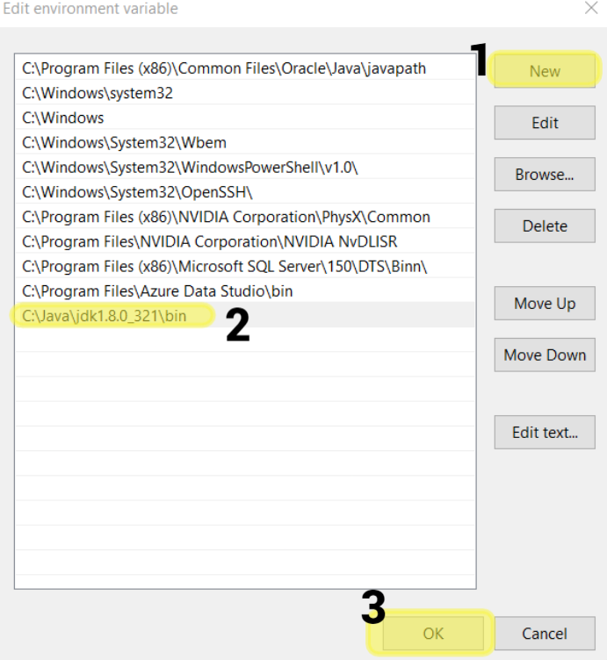

Now, be careful and click on OK in all windows related to the environment variables to save the changes; otherwise, you will need to repeat this process again.

**Java Installation Verification**

To check if Java was correctly installed, open the Windows Command Prompt. You can do this typing Command Prompt in the Windows search bar:

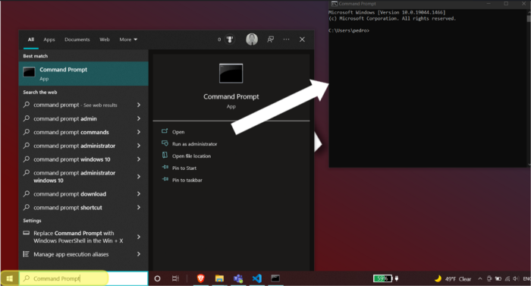

In the command prompt write javac and hit Enter. If you see this output, then Java is working properly:

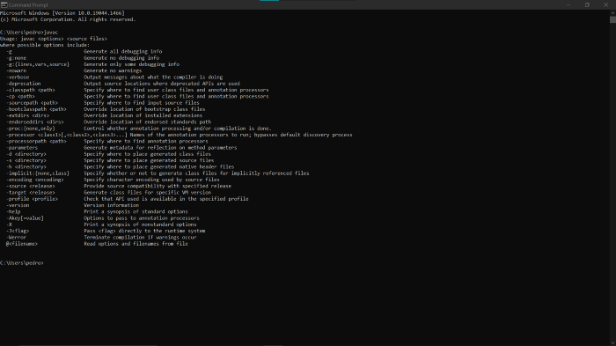

Now, you can check the installed Java version typing java -version:

If you have had no problems, congratulations! that means you have installed Java successfully on your computer.

**Hadoop File System Configuration**

Hadoop Download

Once Java is working properly, you need to download and configure Hadoop File System. To do so, go to [Hadoop official downloads site](https://hadoop.apache.org/releases.html):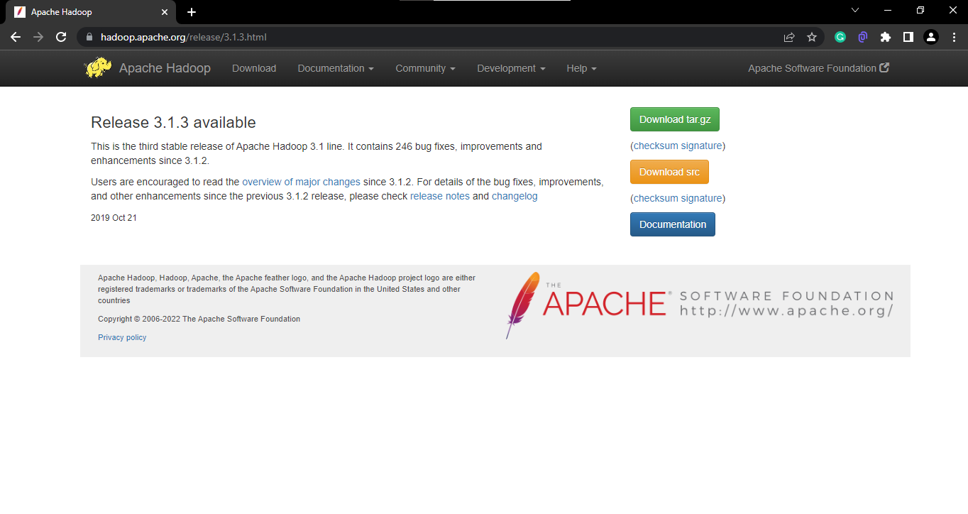

Click on Download tar.qz file

**Hadoop Extraction**

Once you have the .tar.gz file locally, extract it directly in the root of your storage drive (the same folder where you have previously created Java directory) with WinRAR Extract files... option. If you don't do it this way (i.e. extract it on the current folder and after that move the result manually) you may encounter with [Destination Path Too Long error](https://answers.microsoft.com/en-us/windows/forum/all/destination-path-too-long-fix-when-movingcopying-a/3b501b04-2179-438b-af23-38da86d0bb5b) as I did:

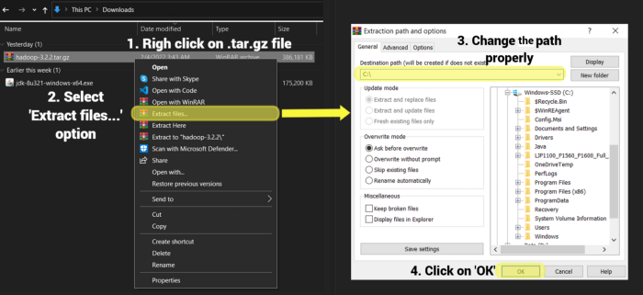

Just before extraction finishes, some error messages may be shown. If this occurs, don’t worry, just ignore them clicking on Close:

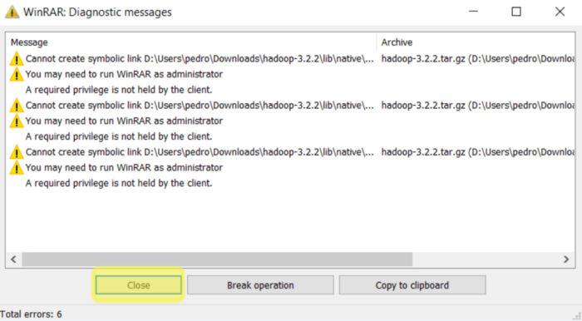

Now, you have Java and Hadoop folders in the same location:

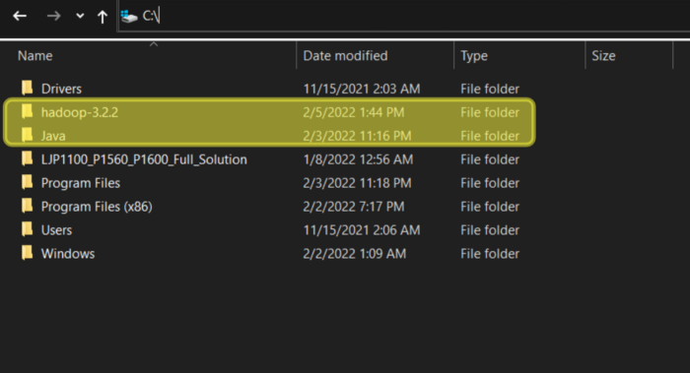

**Hadoop Configuration**

Now, you need to configure some Hadoop files. If you have downloaded the same Hadoop version as me, then you need to go to etc\hadoop folder within the previously extracted Hadoop directory (in my case, the complete path is C:\hadoop-3.1.3\etc\hadoop). Once there, open the following five files with your preferred text editor:

core-site.xml, hadoop-env.cmd, hdfs-site.xml, mapred-site.xml, yarn-site.xml

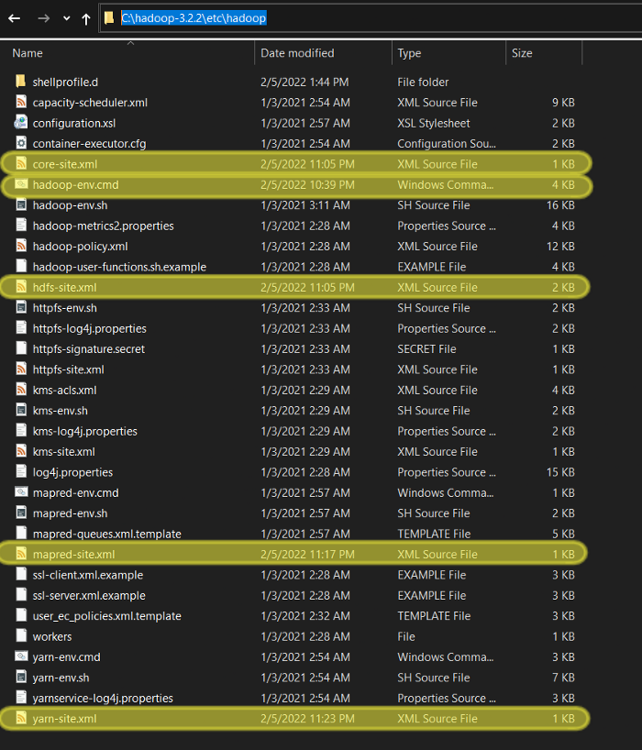

In the core-site.xml you need to set the default Hadoop File System location. Paste this chunk of code inside <configuration> tag:

<property>  
 <name>fs.defaultFS</name>  
 <value>hdfs://localhost:9000</value>  
</property>

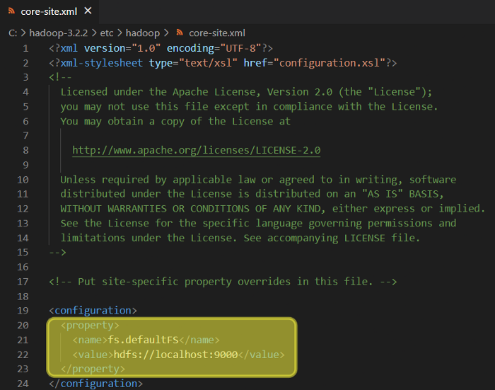

In the hadoop-env.cmd file you need to provide the path to Java. This path was previously used when you set the JAVA_HOME environment variable. In my case, I set the JAVA_HOME value to : C:\Java\jdk1.8.0_321\bin; but now, \bin folder must be removed from the path, i.e. I had to use C:\Java\jdk1.8.0_321 path. You need to assign this path as JAVA_HOME value around line 25:

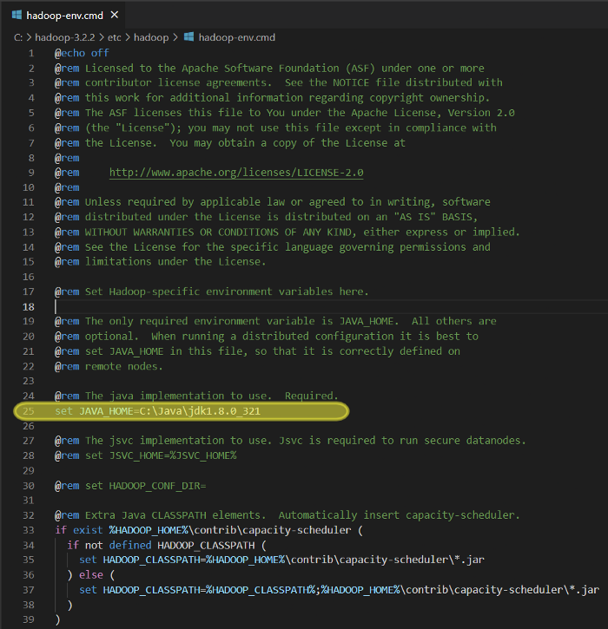

Before you edit hdfs-site.xml file, you need to create some new folders. Go to Hadoop main directory in the root of your storage drive and create data folder inside of it:

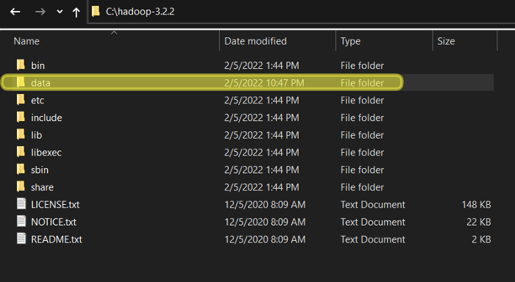

Now, create the datanode and namenode folders inside the new data directory:

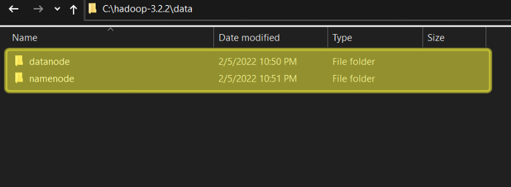

As you can see, datanode folder has the path C:\hadoop-3.1.3\data\datanode and namenode directory path is C:\hadoop-3.1.3\data\namenode.

Once this is done, you need to provide this folders paths as properties in the hdfs-site.xml file. You can copy the following chunk directly into <configuration> tag, just be careful to adjust the datanode and namenode paths according to your machine locations:

<property>  
 <name>dfs.replication</name>  
 <value>1</value>  
</property><property>  
 <name>dfs.namenode.name.dir</name>  
 <value>C:\hadoop-3.1.3\data\namenode</value>  
</property><property>  
 <name>dfs.datanode.data.dir</name>  
 <value>C:\hadoop-3.1.3\data\datanode</value>  
</property>

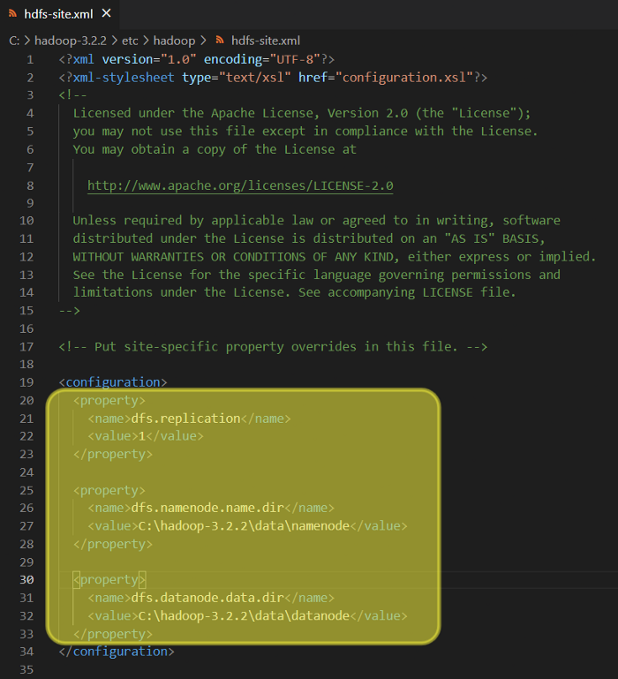

In the mapred-site.xml file you need to set yarn as the MapReduce framework. Copy the following code inside <configuration> tag:

<property>  
 <name>mapreduce.framework.name</name>  
 <value>yarn</value>  
</property>

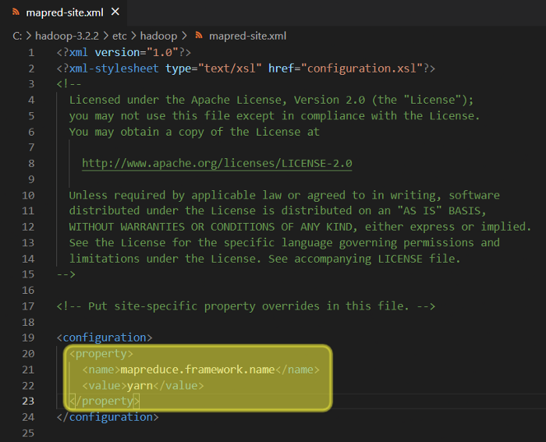

In the last file, yarn-site.xml, you need again to copy some code inside <configuration> tag:

<property>  
 <name>yarn.nodemanager.aux-services</name>  
 <value>mapreduce_shuffle</value>  
</property><property>  
 <name>yarn.nodemanager.auxservices.mapreduce.shuffle.class</name>  
 <value>org.apache.hadoop.mapred.ShuffleHandler</value>  
</property>

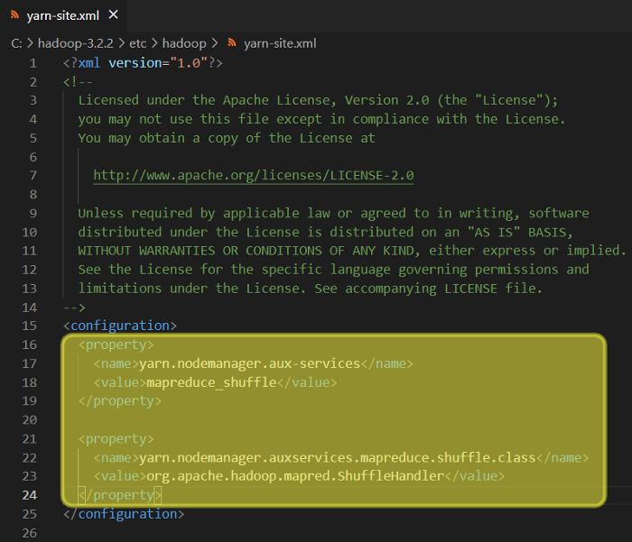

**Hadoop Environment Variable Configuration**

Once all five files are properly edited, now you need to create an environment variable for Hadoop. Open the environment variables window as you did when you created JAVA_HOME variable (recall you can open the Environment Variables typing "Edit the system environment variables" in the Windows search bar) and create the HADOOP_HOME variable, assign the Hadoop bin folder path as its value (in my case: C:\hadoop-3.1.3\bin):

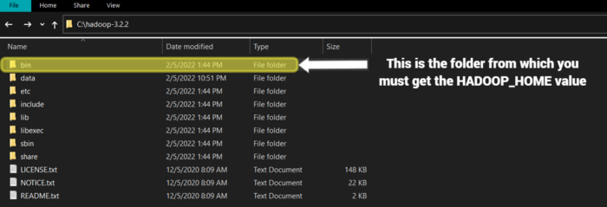

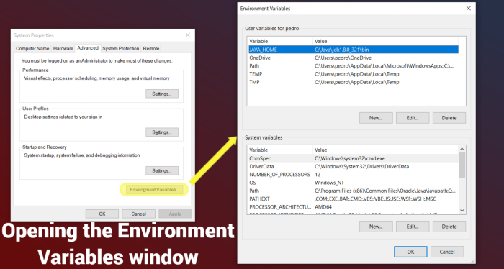

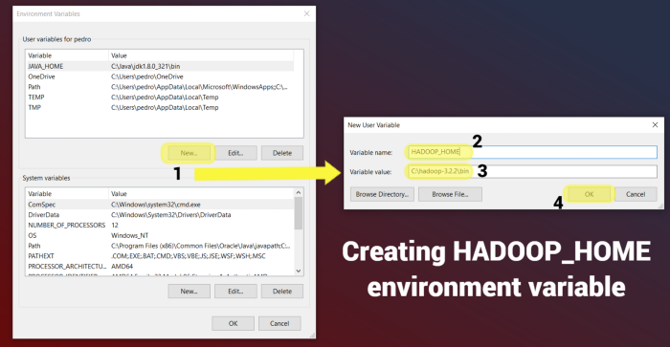

Now, you need to edit the Path system variable to add paths to bin and sbin folders of Hadoop. Both folders are in the root directoryof Hadoop. So, bin path is the same you've just assigned to HADOOP_HOME variable (C:\hadoop-3.1.3\bin); sbin path, in my case will be C:\hadoop-3.1.3\sbin :

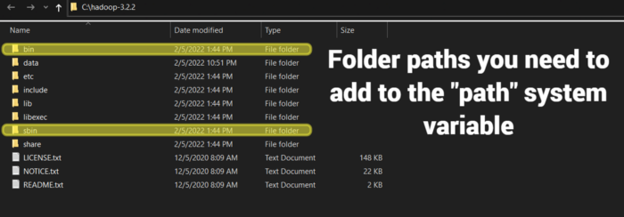

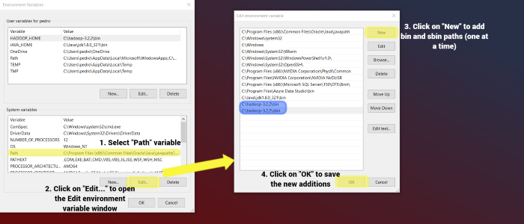

Once done, be careful and click on OK in all windows related to the environment variables to save the changes; otherwise, you will need to repeat this process again.

**Fix of Hadoop ‘bin’ Folder**

Now, you need to fix some configuration files. To do it, you need to replace the Hadoop bin folder with another bin folder which already contains all the files properly configured. First, download this compressed file (https://drive.google.com/file/d/1zuT8G3D2JFkbkdv6fMhnhBOj8YSsgJc-/view).Then, you need to delete bin folder:

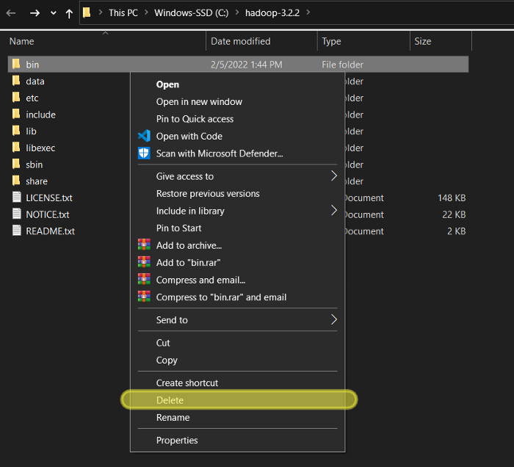

After that, you must decompress hadoop 3.2.1 configuration files.zip in order to move the fixed bin folder to the Hadoop root location:

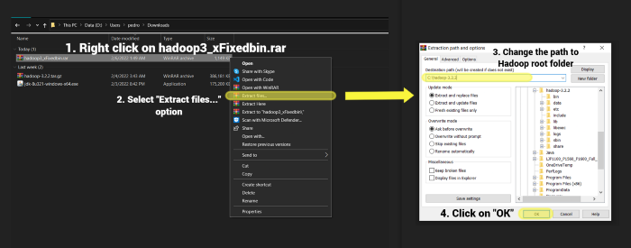

Now, you can check the new and fixed bin folder is in Hadoop root:

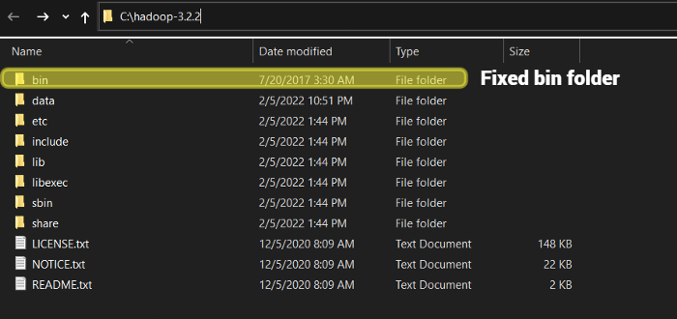

And that’s it, you now have Hadoop File System configured on your computer.

**Hadoop Installation Verification**

Finally, to check if Hadoop is working properly you need to run it. To do so, open a command prompt as administrator. Recall you can do this typing “Command Prompt” in the Windows search bar:

Now, you need to go to the sbin directory inside hadoop folder; in my case, sbin directory is in C:\hadoop-3.1.3\sbin. Once you have typed this path press Enter:

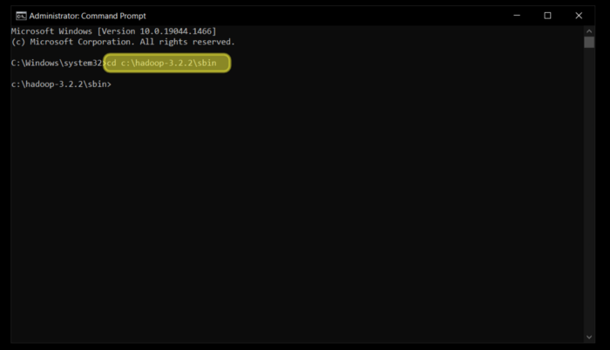

Then, write the command start-all.cmd and press Enter:

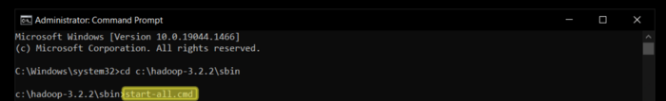

You will see that several command prompts will open. If Hadoop is properly configured, then this four command prompts will remain open and running:

hadoop datanode

hadoop namenode

yarn resourcemanager

yarn nodemanager

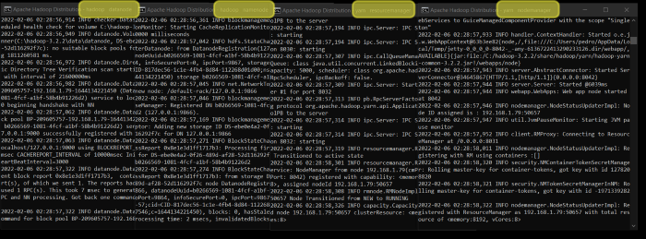

Congratulations, Hadoop is running!

To kill this processes just close the command prompts.